**Modifying Radix Lenses to Survive Low-Cost Sterilization: An Exploratory Study**

Emese Elkind1, K. Barr1, C. Barr1, K. Moga2, T. Garamvolgy2, T. Haidegger2, T. Ungi1, G. Fichtinger1.

1. Queen’s University, Kingston, Canada 2. Obuda University, Budapest, Hungary

**INTRODUCTION:** A major challenge with deploying infrared camera-tracked surgical navigation solutions, such as NousNav [1], in low-resource settings is the high cost and unavailability of disposable retroreflective infrared markers. Developing an accessible method to reuse and sterilize retroreflective markers could lead to significant increase in the uptake of this technology. As none of the known infrared markers can endure standard autoclaving and most places do not have access to gas sterilization, attention is focused on cold liquid sterilisation methods commonly used in laparoscopy and other optical tools that cannot be sterilized in a conventional autoclave.

**METHODS:** We propose to modify NDI Radix™ Lens [1], single-use retroreflective spherical marker manufactured by Northern Digital, Waterloo, Canada. Radix lenses are uniquely promising candidates for liquid sterilization given their smooth, spherical surface. This quality also makes them easier to clean perioperatively compared to other retroreflective infrared marker designs. Initial experiments show that liquid sterilization agents degrade the marker’s retroreflective gold coating (Fig. 1). Hence the objective of this project is to develop a method to protect the Radix Lenses with a layer of coating material that does not allow the sanitizing agent to degrade the coating to enable the lens to survive multiple sanitation cycles while retaining sufficient tracking accuracy. We employed two cold liquid sterilisation agents, household bleach which is a common ingredient of liquid sterilisation solutions and Sekusept™ Aktiv (Ecolab, Saint Paul, MN, USA), which is widely known for sterilizing laparoscopy instruments. Store-bought nail polish and Zink-Alu Spray were used to coat the lenses. Data were obtained by recording five tests each with five rounds of sterilization, each tested with six trials, for a total of 150 recordings. The five tests were as follows: 1) Radix lens coated with nail polish and bleached, 2) uncoated and bleached, 3) coated with nail polish and sanitised, 4) uncoated and sanitised, and 5) coated with Zink-Alu Spray and sanitised. To assess the impact of the sterilization on the lens’s fiducial localization error, two metal marker frames equipped with four sockets designed for the Radix lenses were used. The reference marker frame was secured to a flat table while the other marker frame moved along a fixed path on the table. The position and orientation of the marker clusters were streamed into 3D Slicer using the Public Library for Ultrasound Toolkit (PLUS). A plane was then fit to the recorded marker poses in 3D Slicer using Iterative Closest Point and the marker registration error was computed. Distance from the camera, angle of view, and distance from the edges of the field of view were held constant.

**Fig. 1**: Degrading of the reflective coating on a Radix™ Lens over 5 rounds of sanitization.

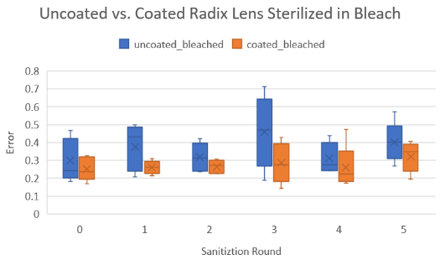

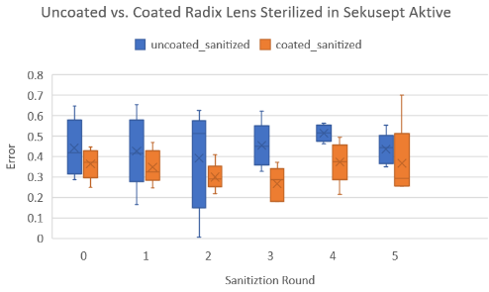

**Fig. 2**: Error after sterilization rounds for Uncoated and Coated Radix Lenses with household bleach (top) and Sekusept Aktive (bottom).

**RESULTS:** With each round of sterilization, the error of coated lenses was lower than the unprotected lenses, and the error showed a slightly increasing trend (Fig. 2). The lenses appeared fainterin the tracking software the lenses appeared fainter while all lenses remained trackable and visible despite the significant removal of reflective coating.

When reflective coating was fully rubbed off the lenses, the tracking software could still localize the markers; however, the lenses did appear much fainter in the tracking software. We observed that the reflective coating rubs off the lens in routine handling, and recoating with Zink-Alu spray can partially restore marker visibility. Using protective nail polish coating prevented the reflective coating from rubbing off altogether.

**CONCLUSIONS:** This exploratory study represents a promising step toward achieving low-cost sterilization of retroreflective infrared markers. Studies with the NousNav system need to be undertaken to measure the extent of degradation in tracking accuracy is tolerable as a side effect of marker sterilization. Before using coated Radix lenses on human subjects, it must be verified that the protective coating (common nail polish in our study) is fully biocompatible and remains undamaged by the cold sterilization agent (Sekusept™ Aktiv in our study.)

**REFERENCES:** [1] NousNav: A low-cost neuronavigation system for deployment in lower-resource settings, International Journal of Computer Assisted Radiology and Surgery, 2022 Sep;17(9):1745-1750. [2] NDI Radix™ Lens (<https://www.ndigital.com/optical-measurement-technology/radix-lens/>)